
THE ASSESSMENT CENTER
Miami Dade College School of Justice
Public Safety, and Law Studies

PHYSICAL ABILITIES TEST INFORMATION

Schedule

The Physical Abilities Test (PAT) is administered every Tuesday and Thursday at 9:00 AM at Miami Dade College North Campus by appointment only. Please send email nac@mdc.edu to request your appointment date. Report 10 minutes before the scheduled time in front of Building 9.

Reporting Information

When reporting for the Physical Abilities Test, you MUST bring the following items (included in package):

- Completed Physician’s Medical Consent Form (must be signed by a Physician)
- Physical Abilities Test Data Sheet
- Signed Liability Waiver
- Government Issued Picture ID (i.e., Driver’s License)
- Payment form and receipt from the Bursar’s Office

North Campus, Building 1, Room 1154
Telephone Number: (305) 237-9310
Email - northbursars@mdc.edu
Hours: Mon—Thurs 8:00 A.M.—7:00 P.M.; Fri 8:00 A.M.—4:30 P.M.

Candidates will not be allowed to participate in the Practice PAT or PAT without and appointment or without the aforementioned items. No Exceptions.
All Physical Abilities Test Fees are non-refundable and non-transferable.

For more information on Physical Abilities Test, please contact The Assessment Center:
(305) 237-1476 | nac@mdc.edu

MDC School of Justice – Rev January 2026

PHYSICIAN’S MEDICAL CONSENT FORM
TO PARTICIPATE IN BASIC PHYSICAL ABILITIES TEST
Last Name: First Name: Mi.:
Last Four # SSN: Agency:
This letter is to inform you of the above-named applicant’s intention to participate in the Pre- Academy Physical Abilities Test. The primary goal of this test is to determine if the applicant is capable of performing MINIMUM standards appropriate for Law Enforcement or Corrections.

The test will consist of a series of job-related physical performance tests that are designed to measure balance, flexibility, muscular endurance and strength, anaerobic capacity, and fine motor skills.
These tests will require MAXIMUM effort and will include the following activities:

COMPONENTS OF THE PHYSICAL ABILITIES TEST (PAT)
Part 1:
Phase A
  - Push-Ups: Pass or Fail
    - Objective: Evaluate upper body strength and endurance
    - Requirements: Candidates must complete 10 push-ups without pause
  - Sit-Ups: Pass or Fail
    - Objective: Assess core strength and endurance.
    - Requirement: Candidates must complete 15 assisted sit-ups within 45 seconds
Phase B
  - Half-Mile Run: Pass or Fail
    - Objective: Evaluate cardiovascular endurance and speed
    - Requirement: Candidates must complete a half-mile run within 6 minutes and 30 seconds
Phase C
  - Obstacle Course: Pass or Fail
    - Objective: Assess candidates' agility, coordination, and problem-solving skills
    - Requirement: Candidates must navigate through a series of obstacles within 3 minutes (traverse)
Part 2: (must be completed same day of passing Part 1 (above) of the PAT or within 30 days thereafter)
Phase A
  - Swim Test: Pass or Fail
    - Objective: Evaluate swimming ability
    - Requirements: When instructed by the instructor, the candidate will push off the wall and swim 25 yards to the opposite side of the pool. Upon reaching the other side, the candidate will touch the wall, immediately turn around, push off the wall again, and swim 25 yards back.
  - Disqualifiers for the swim test
    - If the applicant touches the bottom of the pool at any point during the swim test.
    - If the applicant uses the lane divider for support at any time.
    - If the applicant hangs on the wall for more than 5 seconds while turning around to swim back.
    - If the applicant does not follow the instructions of instructors.
  - Additional Information
    - The applicant may swim using any stroke.
    - The following items are the only ones allowed:
      - Swim goggles (goggles that cover only the eyes), swim cap, earplugs, nose plugs

PHYSICIAN, PLEASE COMPLETE THE FOLLOWING SECTION

I have examined the above-named applicant and evaluated his/her medical history. On the basic of my evaluation, I recommend that:

Subject can participate without restrictions.
Participation is not advisable at this time.

Signature of Physician: Date: Printed Name:
Physician License Number: Licensing State Office Address: Telephone #:

Physician's Stamp

HOW TO PREPARE FOR THE PHYSICAL ABILITIES TEST (PAT)
The Physical Abilities Test (PAT) you are about to take requires maximum effort. The time it takes to complete the test will be recorded as your test effort. Pacing yourself will be important for the successful completion of the test. Proper preparation is imperative to ensure your success. The PAT serves as a vital component of the selection process for candidates applying for the Basic Law Enforcement.

HYDRATION AND NUTIRION
It is recommended to take ample fluid two to three days prior to testing. Consume a light meal two-to-three hours prior to testing to maintain energy level.

STRIVE FOR EXECELLENCE
Remember, your optimal performance is encouraged. Manage your pace cautiously and best of luck.

OBJECTIVES
- To assess candidates' agility, strength, and endurance
- To ensure candidates possess the physical capabilities necessary for succeeding in the Basic Law Enforcement Physical Conditioning program

Part 1:
Phase A
  - Push-Ups: Pass or Fail
    - Objective: Evaluate upper body strength and endurance
    - Requirements: Candidates must complete 10 push-ups without pause
  - Sit-Ups: Pass or Fail
    - Objective: Assess core strength and endurance.
    - Requirement: Candidates must complete 15 assisted sit-ups within 45 seconds
Phase B
  - Half-Mile Run: Pass or Fail
    - Objective: Evaluate cardiovascular endurance and speed
    - Requirement: Candidates must complete a half-mile run within 6 minutes and 30 seconds
Phase C
  - Obstacle Course: Pass or Fail
    - Objective: Assess candidates' agility, coordination, and problem-solving skills
    - Requirement: Candidates must navigate through a series of obstacles within 3 minutes (traverse)
Part 2 (must be completed same day of passing Part 1 (above) of the PAT or within 30 days thereafter)
Phase A
  - Swim Test: Pass or Fail
    - Objective: Evaluate swimming ability
    - Requirements: When instructed by the instructor, the candidate will push off the wall and swim 25 yards to the opposite side of the pool. Upon reaching the other side, the candidate will touch the wall, immediately turn around, push off the wall again, and swim 25 yards back.
  - Disqualifiers for the swim test
    - If the applicant touches the bottom of the pool at any point during the swim test.
    - If the applicant uses the lane divider for support at any time.
    - If the applicant hangs on the wall for more than 5 seconds while turning around to swim back.
    - If the applicant does not follow the instructions of instructors.
  - Additional Information
    - The applicant may swim using any stroke.
    - The following items are the only ones allowed:
      - Swim goggles (goggles that cover only the eyes), swim cap, earplugs, nose plugs

EVALUATION:

- The PAT will be administered by trained personnel in a controlled environment
- Each component will be timed and scored according to predefined criteria
- Candidates will be provided with clear instructions and demonstrations before undertaking each task
- Candidates will be given 3 attempts to pass these physical abilities test. Failure to pass the PAT test will result in the candidate being deferred to an opportunity to retake the PAT test and attend a BLE class provided later on.

The Physical Abilities Test outlined in this proposal is designed to ensure that the candidate is prepared for the 60- hour Basic Law Enforcement Physical Conditioning Program. By adhering to the outlined protocols, we aim to identify individuals who demonstrate the requisite agility, strength, and endurance necessary for success upon acceptance into the Basic Law Enforcement Program.

MDC School of Justice – Rev January 2026
PHYSICAL ABILITIES TEST (PART 1) COURSE LAYOUT

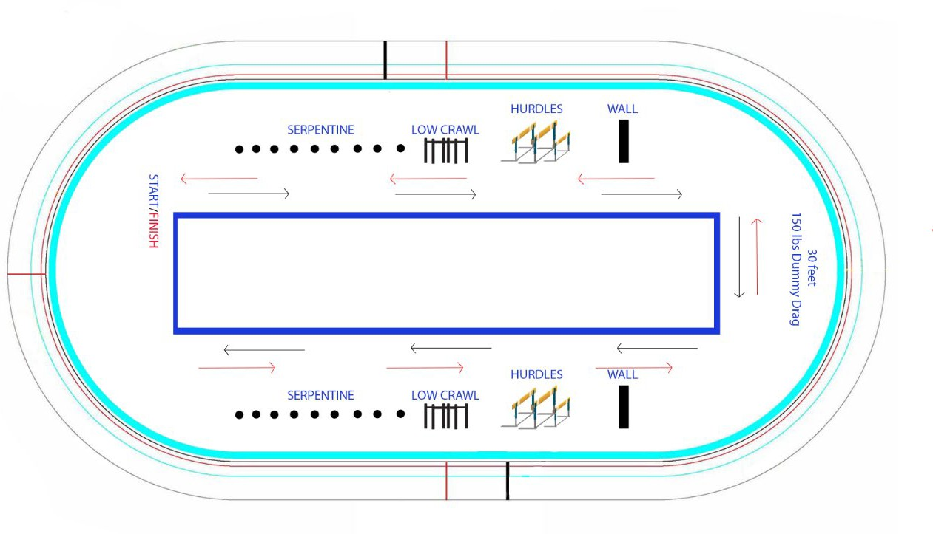

MDC School of Justice – Rev January 2026
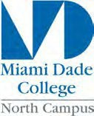

Miami Dade College Assessment Center
(305) 237-1476
NAC@MDC.EDU

JOB RELATED PHYSICAL ABILITIES TEST TESTING DATA SHEET

Law Enforcement
❒
Test Date:
Agency: Independent: Name: Last Four # SSN : Address: City: Zip:

Phone: Race:
NOTE: PHOTO I.D. MUST BE PRESENTED UPON REQUEST
Age: Height: Weight:
◻ Male ◻ Female

I, , in consideration of being allowed to take the job related test, do hereby agree and a vow that I shall not hold liable the school of Justice should I incur any injuries or disabilities. I have been orientated to the course, given the opportunity to view a video tape of the course, and have had any questions satisfactorily answered regarding the test.

Date

Signature

Stop here. Next section to be completed by Training Advisor

MDC, SOJ BLE Candidates – Evaluation
☐ PASS
☐ FAIL
☐ Retest (Full PAT – Failed Part 1)
☐ Retest (Swimming Only – Passed Part 1)

Independent / Sponsored Candidates – Evaluation
☐ PASS (without Swimming)
☐ PASS (with Swimming)
☐ Retest (Full PAT – Failed Part 1)
☐ Retest (Swimming Only – Passed Part 1)
*Agency does NOT require swimming portion. Candidate Signature: ____________

Test administrator’s Initials: (1) (2)
Date:
Comments and Observations:

Training Advisor Lloyd Mitchell Physical Fitness Coordinator


THE ASSESSMENT CENTER
Miami Dade College
School of Justice, Public Safety, and Law Studies
(305) 237-8012
nac@mdc.edu
LIABILITY WAIVER
PHYSICAL ABILITIES TEST
LAW ENFORCEMENT

I, , do hereby agree to release Miami Dade College, The School of Justice Department, The Assessment Center, and all employees thereof, from any and all claims and liability for personal injury or damages arising from my activities while performing the Law Enforcement Physical Abilities Test on the premises of Miami Dade College, North Campus.

By my execution here of this day of , 20 , I hereby certify I have read and understand the above agreement.

Signature Date

Name (Printed)

Address

City, State, Zip

Last Four Digits of SSN Primary Phone Number
In case of emergency, please contact:

Name of Contact Person Phone number of Contact Person

THE ASSESSMENT CENTER

Miami Dade College
School of Justice, Public Safety, and Law Studies
(305) 237-1476
nac@mdc.edu

Instructions
PAYMENT FORM
PHYSICAL ABILITIES TEST
LAW ENFORCEMENT

- Step One - Complete all of the required fields below.
- Step Two - Once you are finished, save and print.
- Step Three - Visit the Bursar’s Office to make the payment prior to your test.
  - North Campus, Building 1, Room 1154
  - Telephone: (305) 237-9310 – Select Option #1 for North Campus
  - Hours: Mon—Thurs 8:00 A.M.—7:00 P.M.; Fri 8:00 A.M.—4:30 P.M.
Name:
Date:
Last Four # SSN:
Email Address:
- Law Enforcement Physical Abilities Test (includes practice test) + Swimming ($90.00)
- Law Enforcement Physical Abilities Test (practice test not included) + Swimming ($80.00)
- Law Enforcement Physical Abilities Test + practice test included (no Swimming) ($55.00)
- Law Enforcement Physical Abilities Test (practice test and swimming not included) ($45.00)
- Swimming Test Only ($45.00)
- Duplicate Test Results ($15.00)
- Missed Appointment Fee ($15.00)

I, |  | understand the following:
- The Physical Abilities Test fee must be paid prior to arriving at the testing site.
- It is my responsibility to call or visit the Bursar’s Office to make my payment.
- Payment must be made by credit or debit card.
- All fees are non-refundable and non-transferable.
- Receipts are valid for thirty (30) days from payment date.
Candidate Signature: |  | Phone Number:
Email Address:
Bursar’s Authorization to Collect Test Fee for Physical Abilities Test

ASSESSMENT CENTER
QUAL | OPERATING UNIT | FUND CODE | ICS | DEPT ID | CAMPUS CENTER | GL CODE
N31201 | NH01 | 301 | 4A22001 | 350090 | 1000 | 40920

Payment Receipt |  |  | Cashier Name
Cashier Signature |  |  | Date:
AC Staff |  |  | Date:

